DCS 234: Software Engineering Theory

2005-2006

Queen Mary University of London

Project Plan and Specification

Monopoly Board Game



Group X
Ossie Ardiles (ossie@dcs.qmul.ac.uk)
Glenn Hoddle (glenn@dcs.qmul.ac.uk)
Ricky Villa (ricky@dcs.qmul.ac.uk)
Graham Roberts (gr@dcs.qmul.ac.uk)
Steve Perryman (sp@dcs.qmul.ac.uk)

Version 1.00
9 November 2005

Table of Contents

1. INTRODUCTION 3
2. ORGANISATION 4
2.1 Project Roles and Responsibilities 4
2.2 Project Roles applied to the group project 6
2.3 Monitoring and Controlling Mechanisms 7
3. Requirements Specification 8
3.1 Must Have Requirements 8
3.2 Should Have Requirements 9
3.3 Could Have Requirements 10
3.4 Non-Functional Requirements 10
3.5 Terms and components of the game 11
3.6 The Text Based Console version of the Game 16
3.7 Issues and Ambiguities 17
3.8 Use Case Diagram and Descriptions 19
4. Schedule 26
4.1: Formal Deliverables Deadline 26
4.2 Activities and tasks 27
4.3 Task dependencies, schedule of tasks and total effort: 36
4.4 Individual work breakdown for increment 1 43
5. Configuration Management 46
6. References 47

1. INTRODUCTION

- The aim of the 2005-06 software engineering group project (referred to as simply the project in the remainder of this document) is to create a stand-alone Java based implementation of the classic board game MONOPOLY.
- This project is to be developed by a team of 6 members, the group members are as follows:
Member AB Member CD Member EF Member GH
Member IJ Member KL

Special hardware and software requirements:

There are no special hardware requirements; the project is to be a stand-alone Java based implementation of the game. It is essential that there should be enough memory available in order to run the game.

On the departmental student file-server the group has a repository in order to place files from where the assessors will monitor the progress of the development of the group project. Each group member has access to this repository.
In brief the list of software required is:
- Java Runtime Environment Version 5.0
- Eclipse IDE
- Together : plug-in for Eclipse IDE
- JUnit : testing tool integrated with Eclipse IDE
- Star Team : plug in with Eclipse IDE
- SSH Secure File Client
- Smart Draw Trial Version

  - This report outlines the group strategy to implement the project, highlighting the following aspects:
- Organisation: This section explains the organisational structure of the group with respect to the project and highlights the roles played by individual members.
- Requirements Specification: This section highlights the group’s interpretation of the project specification. The requirements will be divided into smaller sub- requirements, and these will be clearly numbered in order to ensure traceability during the course of project implementation. This section will also highlight any assumptions and ambiguities that are found during the analysis of the requirements. Basic Use-Case diagrams and descriptions will be a part of this section.
- Schedule: This section of the report will detail the proposed work breakdown structure by identifying the activities and tasks, the dependencies between various tasks and the effort to be spent on the tasks.
- Configuration Management Plan: This section will define the way documents are managed by the group.
- References: This section will list the references used for the project plan and specification.

2. ORGANISATION
This section describes the various roles in a software group project.

2.1 Project Roles and Responsibilities

Table 1: The roles in a group project

ROLE | RESPONSIBILITY
Project Manager | - Planning and monitoring the project  - Take steps to ensure team works as a unit  - Responsible for breakdown of work into sub tasks  - Allocation of tasks  - Ensure members are doing their fair share of work  - Anticipate problem areas and take steps to combat potential problems  - When problems do arise, act as an arbitrator and help the group to reach a solution amicably.  - Act as a liaison between the consultant and the group  - Responsible for group meetings  - Follow-up with members if required tasks are being carried out.
Analysts | - Responsible for preparing the requirements specification  - Update specification to meet new requirements

ROLE | RESPONSIBILITY
Designers | - Responsible for producing the High Level design
Programmers | - Responsible for the implementation of the Text Based console  Version of the Game  - Research concepts of User-Friendly GUI  - Responsible for the GUI Board Design  - Responsible for ensuring that the work of team as a whole binds into one unit.
Tester | - Unit Testing: Test the methods as they are written  - Integration Testing: Test the entire code  - Installation Testing: Test that the code can be installed and executed as defined in the requirements
Configuration Manager  &  Group Repository Manager | - Responsible for the website  - Responsible to ensure that the group repository is kept up-to-date  - Ensure that the document naming scheme is maintained  - Responsible for backing up the group repository at regular intervals.
Secretary  &  Minute Taker | - Responsible for taking the minutes of the meeting  - Inform members of the date and time of next meeting  - Ensure that the meetings which are held between the group members in order to discuss specific issues are documented.

2.2 Project Roles applied to the group project

This project is to be a learning experience and each member should get substantial amounts of practice in all the aspects of software engineering.
Each person must be involved in: writing some of the documents; editing documents; writing and testing code. Therefore the roles are assigned to team members but every member will need to get involved with every aspect in order to make the project successful.
Table 2 : Project Roles for the Project

Role | Assigned To :
Project Manager | AB
Documents Editor | CD
Analysts | EF, GH ,IJ
Designers | AB, KL
Lead Programmer | KL
Programmers | AB, CD ,EF ,GH, IJ
Tester  - Integration Testing  - Unit Testing  - Installation Testing | EF, GH  AB, CD, EF ,GH ,IJ, KL  CD, KL
Configuration Manager & Group Repository Manager | IJ
Secretary & Minute taker | GH

2.3 Monitoring and Controlling Mechanisms

2.3.1 Group repository:
The group’s progress will be judged by the consultant and other external evaluators on the basis of the documents available in the group repository. It is essential that the minutes of meetings, design documentation and code increments that are placed in the group directory are up-to-date.

2.3.2. Consultant meeting:
Every week, a 15-minute group meeting with the group consultant will be held so that the consultant can monitor and comment on the group’s progress. It is a chance for group members to clear doubts on any aspect of the project.

2.3.3. Checkpoint meeting:
Weekly checkpoint meetings will be held by the group to review the progress of the tasks allocated to each group member.
These are the points that will be discussed at each meeting:
- Review the tasks assigned to each group member during the last meeting.
- Discussion of any concerns or problems encountered.
- Task allocation for the following week to each group member.

3. Requirements Specification

This section deals with the requirements specification, the sub-sections deal with the following:
3.1 Must Have Requirements: These are the core requirements of the system.
3.2 Should Have Requirements: These are the additional requirements for the system
3.3 Could Have Requirements: These requirements are the gold plating of the project.
3.4 Non-functional Requirements: These requirements are in addition to the functional requirements of the project.
3.5: Terms and components of the game: This section defines the “hardware” i.e. the components of the game.
3.6 The Text Based Console version of the Game: This section details how the text based version game is to be played.
3.7 Issues and ambiguities
3.8 Use Case Diagrams and Descriptions

3.1 Must Have Requirements
1 Provide a text based console of the Monopoly Game:
For this requirement a faithful implementation of the basic game for 2-6 players must be provided.
  - There must be a stylised overview of the game board above the console window.
  - The user input and system output must be via a text based console window.
  - Provide a set of commands that enable the game to be played

- GUI version of the basic game:
This requires the implementation of a GUI interface to enable users to experience the same ‘look and feel’ as the original board game.
  - Implement a GUI that looks like the original board game
  - The GUI Version must be based around the same core classes as the text based version of the game.
- Support basic computer players:
  - The game must be able to provide computer players to compete against human players.
  - The computer player must abide by the rules of the game
  - The computer player must be able to provide a basic challenge to any human player.
- Save the game
  - It must be possible to save the state of the game at any stage to a file.
  - Java serialisation should not be used in order to achieve this requirement.
- Load a game
  - It must be possible to load a game which was saved to a file.
  - The loaded file must restore the game to its state at the time it was saved.
- Support alternative boards:
This applied to the GUI version of the game only.
  - Provide GUI version of the first alternative game board
  - Provide GUI version of the second alternative game board
  - Implement the idea that the players can choose which of the three boards they wish to play on start-up.
- Implement undefined additional requirement:
There will be a new requirement announced in week 18; the group is expected to be able to accommodate the new requirement.

3.2 Should Have Requirements
- Online help system:
  - An html-based Help system must be provided with the game
  - It should be possible to invoke the Help system from the GUI.
- Redefine location information:
  - Provide an implementation of an ‘administrative user’
  - The administrative user must be able to redefine the names and values of any site on the standard board.
  - When a site name and value is changed, the corresponding title deed should automatically be changed.
  - Changes to the rent information on the title deeds should be possible.
  - Any changes to site value must preserve the consistency that site values are non-decreasing in order from GO.
- Edit/Add/Remove Cards
The administrative user must be able to edit/ add/ remove community chest or chance cards while setting up the game
- User defined tokens
11.1 At the start of a game the user should be able to select their own token from a range of tokens
11.2 The tokens must be represented as graphical icons.

3.3 Could Have Requirements

- Support intelligent players
12.1 The computer players must provide a good challenge to human players
12.2 There should be defined strategies for the computer players
12.3 Human players must be able to choose which of the 2 levels of intelligence they require for the computer players i.e. basic computer player or intelligent computer player.
12.4 If this requirement is implemented the details must be provided about the ‘intelligence’ in the final report and how this implementation was achieved. These details must also be in the PowerPoint file that accompanies the final code delivery.

- Innovative features
This feature could cover anything from novel GUI features, or other features that improve the overall game experience. The group will research ways of implementing this requirement once the text based version of the game has been developed.

3.4 Non-Functional Requirements

- Ease of installation:
The code must be packaged up so that it can be executed from a single file on any machine.
- Ease of use:
This requirement is judged from the perspective of a Monopoly player who has not played the group’s version of the game. The elegance and attractiveness of the interface will be taken into consideration.
- Reliability and robustness:
This will be judged on the basis of the extent to which the code runs without failing. In order to ensure that this reliability is achieved stress testing must be carried out on the code.
- Efficiency : speed
The response time to GUI requests and computer player actions must be fast.
- Efficiency : memory
This will be judged on the amount of memory used when running, the size of application files and the size of saved game files.
- Quality of “intelligence of computer players”
This will involve an assessment of requirements 3 and 12.
- Reusability:
This will be judged on the extent to which the application or components of the application can be reused in other related applications. A test of this will be the implementation of requirements 6 and 9, since these can be implemented only if the design supports reusability.
- Maintainability
This is the extent to which it is possible to change the code in order to implement new/changing requirements. This will be tested in the implementation of requirement 7.

3.5 Terms and components of the game
- Board: The main playing area is made up of a board of 40 squares with 10 squares per side in the text based version and the basic GUI Board. The alternative boards may have different dimensions.
- Square: There are two main categories of squares on the board. The first category of squares can be bought by a player - known as Properties. There are three types of properties - sites, utilities and stations. The second category consists of squares that cannot be purchased by anyone. These include squares such as the “GO”, “Go to Jail”, “Jail”, “Community Chest”, “Chance”, “Pay income tax”, “Free Parking”, etc.
- Dice: In order to play the game the player rolls the dice and his token is moved according to the amount shown on the dice.
- Playing Tokens: Each player can choose a playing token at the start of the game, the playing token is the identifier for the player during the game. The token is moved along the game board during the course of the game.
- Title Deed cards: Each property has a Title Deed card; which a player receives as proof of ownership when he buys a property. Site title deed cards contain the purchase price, mortgage value and rent for vacant and non-vacant properties. Stations and utilities title deed cards contain the purchase price and the mortgage value.
- Chance cards: When a player lands on a “Chance” square he has to pick a Chance card and follow the instructions on the card.
The Chance Cards:
- Advance to Trafalgar Square. If you pass “GO” collect £200
- Your building loan matures receive £150
- Pay School fees of £150
- Bank pays you dividend of £50
- Advance to Pall Mall. If you pass “GO” collect £200
- Advance to Mayfair
- Make General Repairs on all of your hoses, for each house pay £25, for each hotel pay £100
- Advance to “GO”
- Go back three spaces
- Speeding fine £15
- Get out of Jail Free
- Go to Jail directly, Move directly to Jail. Do not pass “GO” Do not collect £200
- You are assessed for street repairs £40 per house, £115 per hotel
- You have won a crossword competition collect £100
- “Drunk in charge” Fine £20
- Take a trip to Marylebone station and if you pass go collect £200

- Community Chest cards: When a player lands on the “Community Chest” Square he has to pick a Community card and follow the instructions on the card.

The Community Chest Cards
- Pay a £10 fine or take a Chance
- Doctor’s fee pay £50
- Pay your insurance premium £50
- Income tax refund collect £20
- Go back to Old Kent Road
- You inherit £100
- Advance to Go
- It is your birthday collect £10 from each player
- Annuity matures collect £100
- Get out of Jail free
- Bank error in your favour collect £200
- From sale of stock get £50
- Go to Jail directly, Move directly to Jail. Do not pass “GO” Do not collect £200
- Pay hospital £100
- You have won second prize in a beauty contest collect £10
- Receive interest on 7% preference shares £25

- Houses : A player can buy houses from the Bank and erect them on properties when he has all the properties of a colour-group
- Hotels: A player can buy a Hotel from the Bank when he has 4 houses on each property of a complete colour group.
- Bank: The bank holds money, title deed cards, houses and hotels prior to purchase and use by the players. The Bank pays salaries and bonuses, sells and auctions properties, sells houses and hotels and loans money required on mortgages.
- Player: A player is one who plays the game; in this game we have 2 categories of players – human player and computer player.

Figure 3: Snapshot of the Game Board

: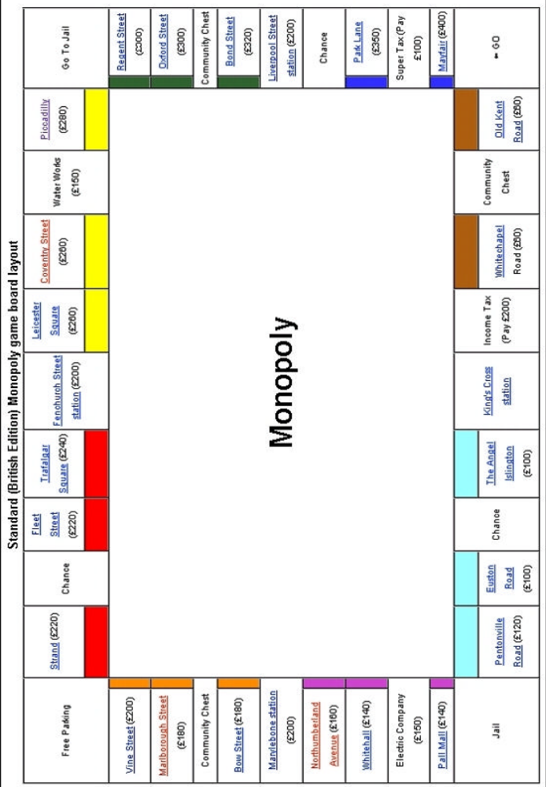

Table 4: Title Deed Details for Sites

 | Name | Price | Rent only | Rent +  1 house | Rent  +  2 houses | Rent  +  3 houses | Rent  +  4 houses | House | Hotel | Mortgage value
 | Old Kent Road | 60 | 5 | 25 | 75 | 225 | 350 | 36 | 180 | 30
 | Whitechapel | 60 | 5 | 25 | 75 | 225 | 350 | 36 | 180 | 30
 | The Angel Islington | 100 | 8 | 42 | 125 | 375 | 583 | 60 | 300 | 50
 | Euston Road | 100 | 8 | 42 | 125 | 375 | 583 | 60 | 300 | 50
 | Pentonville Road | 120 | 10 | 50 | 150 | 450 | 700 | 72 | 360 | 60
 | Pall Mall | 140 | 12 | 58 | 175 | 525 | 817 | 84 | 420 | 70
 | Whitehall | 140 | 12 | 58 | 175 | 525 | 817 | 84 | 420 | 70
 | Northumberland Avenue | 160 | 13 | 67 | 200 | 600 | 933 | 96 | 480 | 80
 | Bow Street | 180 | 15 | 75 | 225 | 675 | 1050 | 108 | 540 | 90
 | Marlborough Street | 180 | 15 | 75 | 225 | 675 | 1050 | 108 | 540 | 90
 | Vine Street | 200 | 17 | 83 | 250 | 750 | 1167 | 120 | 600 | 100
 | Strand | 220 | 18 | 92 | 275 | 825 | 1283 | 132 | 660 | 110
 | Fleet Street | 220 | 18 | 92 | 275 | 825 | 1283 | 132 | 660 | 110
 | Trafalgar Square | 240 | 20 | 100 | 300 | 900 | 1400 | 144 | 720 | 120
 | Leicester Square | 260 | 22 | 108 | 325 | 975 | 1517 | 156 | 780 | 130
 | Coventry Street | 260 | 22 | 108 | 325 | 975 | 1517 | 156 | 780 | 130
 | Piccadilly | 280 | 23 | 117 | 350 | 1050 | 1633 | 168 | 840 | 140
 | Regent Street | 300 | 25 | 125 | 375 | 1125 | 1750 | 180 | 900 | 150
 | Oxford Street | 300 | 25 | 125 | 375 | 1125 | 1750 | 180 | 900 | 150
 | Bond Street | 320 | 27 | 133 | 400 | 1200 | 1867 | 192 | 960 | 160
 | Park Lane | 350 | 29 | 146 | 437.5 | 1312.5 | 2042 | 210 | 1050 | 175
 | Mayfair | 400 | 33 | 167 | 500 | 1500 | 2333 | 240 | 1200 | 200

Stations and Utilities:
The four stations (Kings Cross, Marylebone, Fenchurch Street, and Liverpool Street) are each worth £200. Rent is based on the number of stations that the player owns: £25 for one, £50 for two, £100 for three, and £200 for all four. Each station has a mortgage value of £100.
The two utilities (Electric Company and Water Works) are each worth £150. If a player owns either, rent is equal to the amount shown on the dice times 4. If a player owns both, rent is equal to the amount shown on the dice times 10. Each utility has a mortgage value of £75.

3.6 The Text Based Console version of the Game
This is an insight into the way the group aims to achieve the implementation of the text based console version of the game. This is not a comprehensive list; it will be updated once the team have prepared the detailed design, class diagram and the sequence diagrams for the game.

3.6.1: Start-up:
The Monopoly game is played in a series of rounds. During a round each player takes one turn.
- The text based version on start-up will ask players to choose a token from a list of tokens; once a token is taken by a player it cannot be used by any other player.
- The Bank distributes to each player £1500, the rest of the money and equipment is retained by the Bank until required.
- Each player rolls the dice, the person who roles the highest total will play first and play passes to the person on his left.
- In order to play, each player throws 2 dice and his token will be moved in the clockwise direction around the board by the number of spaces indicated by the die.
  - When it is a player’s turn, the name of the player and the current location of the player is displayed.
  - Then the game asks if the player is ready to roll the die; on receiving the answer as Yes, the game will display the total of the die. The value on each dice is shown separately. This is in order to display whether the player has thrown a “Double”
  - Then game will advance the player’s token by the number of squares of the die total and will then display the new location of the token and display possible options available to the player.
- The token will remain in the space landed on and proceed from that point when the player has his next turn.

3.6.2 Landing on Property Squares:
- When a player lands on a Property square that is un-owned, the player can buy it. In order to buy the player must pay the Bank the price stated on the space. As proof of ownership the player will receive the Title Deed.
  - The console will inform the player, you have landed on “XYZ”, and this is a site belonging to the “colour” group (in case of a utility / station this will not apply). The cost of “XYZ” is £ AB. Do you wish to buy XYZ (Y/N)?
- If a player decides not to buy a Property that he has landed on, the Bank will launch an Auction and the property will be sold to the highest bidder.
- Auction Format: The Bank will start with the player seated to the left of the player whose turn it is and the text based console will prompt the player to enter their bid. After each player has been given a chance to enter their bid, the text based console will display the highest bid amount and prompt if any player wants to enter a higher amount, if a player enters a higher amount at this point he must enter his identity and bid amount. The property will be sold to the player with the highest bid amount.

- When a player lands on a Property that is owned by another player, he is required to pay rent to the owner.
- The text based console will display a message to inform the player, “You have landed on XYZ, this is owned by Player A, rent of £A is deducted from your account”.

3.6.3 Landing on Income Tax:
- When a player lands on the Income Tax square the text based console offers the following options to the player:
You have landed on Income Tax Square, you have 2 options:
1] Estimate your tax and pay the Bank £200
2] Pay 10% of your total worth to the Bank.
What do you choose (1/2)?
According to the player’s response the income tax is deducted from his account.

3.7 Issues and Ambiguities
The group’s interpretation of aspects of the game:
- The instructions on Chance and Community Chest cards will be the same as the instructions on the cards in the Standard British Edition of the Game.
- The names and values of the property are the ones on the Standard British Edition of a Monopoly game.
- Banker: The banker will not be a player; our implementation of the game will have the Banker built into the game interface.
- Landing on a site that is owned: The implementation will be such that when a player lands on site that is owned, the text based console will inform the player that rent has been deducted from his account.
- Concept of Money: This is a software version of the game; in the text based console implementation the concept of denominations of notes will not be used. The implementation will be implemented by having running totals of the player’s money.

3.8 Use Case Diagram and Descriptions

Figure 5: Use Case Diagram

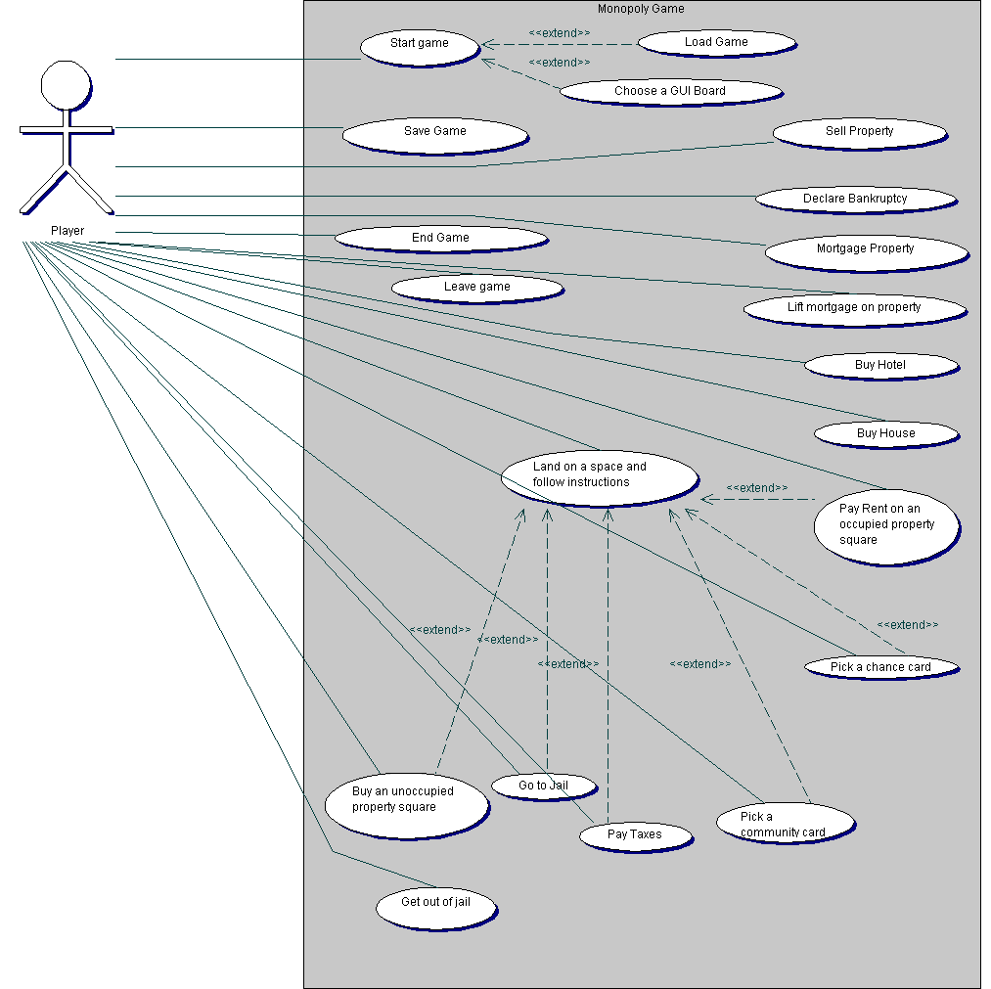

USE CASE DESCRIPTIONS
The actor for the use cases of the Monopoly game will be the Player. The Bank is to be considered as part of the game; hence it will not be modelled as an actor.

3.8.1 Use Case: Start a game

The player starts a new game.
- The system records the date and time of the start of the new game.
- The first player specifies the number of players who will play the game.
- The system asks each player to input their choice of token.
- The players roll the dice.
- The system records the dice roll.
- The player who rolled the highest starts first and the rest of the players follow.
- The system records details and interacts with the players during the course of the game.
Extension points:
- At step 1, player chooses to load a saved game.
- At step 1, player chooses a GUI Board from a choice of three GUI Boards.

3.8.2 Use Case: Load Game - Extends Use Case Start game

- The player chooses to load a previously saved game on start-up.
- The system displays a list of saved games
- The player chooses a game from the list.
- The system loads the saved game.
Exception: There are no games saved on the system.

3.8.3 Use Case: Save Game

- The player requests the system to save the current game that is in play.
- The system asks the player for the name of the game to be saved.
- The system saves the current state of the game with the name supplied by the player, along with the date and the time

3.8.4 Use Case: Leave the Game

- The player chooses to leave the game.
- The system removes all details of the player.
- The properties owned by this player will be returned to the bank. These properties will be available for other players

3.8.5 Use Case: End the game
- The player chooses to end the game
- The system will ask the player whether they want to save the game.
- The player decides to save game
- The progress of the game is saved into a file, where it can later be loaded.
- The player decides not to save game
- The system will show the name of the winner by calculating the balance and properties owned by the player.

3.8.6 Use Case: Land on a space and follow instructions

Description: It is the player’s turn and he lands on a space on the board game. He has to carry out the instructions on the space he has landed on according to the game rules.
- A player rolls two dice.
- The system returns the total of the two dice and the details of the location that the player has landed on.
Extension points: When the system specifies location details at step 2:
- If the square is unoccupied the player acts according to “Buy an unoccupied property square”
- If the square is occupied the player acts according to “Pay Rent on an occupied property square”
- If the square instructs the player to pick a Chance card the player acts according to “Pick a chance card”
- If the square instructs the player to pick a Community Chest card the player acts according to “Pick a community card”
- If the square instructs the player to pay taxes the player acts according to “Pay Taxes”
- If the square tells the player go to Jail, the player follows the instructions
“Go to Jail”

3.8.7 Use Case: Buy an unoccupied property square

Extends Use Case Land on a space and follow instructions

- The system displays the information the player has landed on an unoccupied property square, along with the name and the price of the property square.
- The system asks player if he wants to buy the property square
- The player agrees to buy the property square.
- The cost of the property square is deducted from the player’s account
- The title deed of the property square is recorded as belonging to the player.
Alternative flow: At step 2:
- The player does not want to buy the property square
- The bank conducts an auction for the property square.

Exception: At step 4
The funds in the player’s account are insufficient to buy the property square.

3.8.8 Use Case: Pay Rent on an occupied property square

Extends Use Case Land on a space and follow instructions

- The system informs the player that he has landed on a property square occupied by another player and displays the rent for the square.
- The rent for the square is deducted from the player’s account and added to the account of the player who owns the property.

3.8.9 Use Case: Pick a chance card
Extends Use Case Land on a space and follow instructions

- The system informs a player he has landed on the space that says “Pick a chance card”.
- The player requests to pick a chance card.
- The system returns the instructions on a random chance card from the set of chance cards.
- The player carries out the instructions on the Chance card.

3.8.10 Use Case: Pick a Community chest card
Extends Use Case Land on a space and follow instructions

- The system informs a player he has landed on the space that says “Pick a community chest card”.
- The player requests to pick a community chest card.
- The system returns the instructions on a random community chest card from the set of community chest cards.
- The player carries out the instructions on the community chest card.

3.8.11 Use Case: Pay Taxes
Extends Use Case Land on a space and follow instructions

- The system informs the player that he has landed on a square that requires him to pay tax.
- The system displays two options to the player i.e. estimate tax at £200 and pay the bank £200 or pay 10% of total worth to the bank.
- The player chooses one of the two options.
- The system deducts the tax from the players account.

3.8.12 Use Case: Get out of Jail
Pre-condition: It is the player’s turn and he is in Jail.
Flow 1:
- The player has a “Get of Jail Free” card; he returns this card to the bank.
- The system records that the player is out of Jail.
Flow 2:
- The player pays the fine to get out of Jail
- The system deducts the fine amount from the player’s account.
- The player can roll the dice and continue with play.
Flow 3:
- The player attempts to throw doubles on any of his next three turns.
- The system keeps track of the number of times the player has tried, if he throws doubles the system records the player as out of jail and moves his token forward by the total of his dice roll.
- The player fails to throw doubles on his next three turns.
- The system deducts the fine from the player’s account and then moves him forward by the total of his dice roll.

3.8.13 Use Case: Buy House

Pre-Condition: It is the player’s turn and the player owns all the properties of a colour group.
- The player requests to buy a house from the Bank.
- The system returns that the player can buy a house.
- The system deducts the cost of the House for the property as shown on its Title Deed card.
Post-condition: The player must build houses evenly.

3.8.14 Use Case: Buy Hotel

Pre-Condition: It is the player’s turn and the player has 4 houses on each property of a complete colour group
- The player requests to buy a hotel from the Bank.
- The system returns that the player can buy a hotel.
- The player returns the 4 houses from the property on which he wants to build his hotel.
- The system deducts the cost of the Hotel for the property as shown on its Title Deed card.

Post-condition: Only one hotel can be built on each site.

3.8.15 Use Case Mortgage Property
Pre-Condition: It is the player’s turn to play, and he owns the property which he wants to mortgage.
1. The player informs the system which property he wants to mortgage.
2. The mortgage value is credited to the player’s account.
Post Condition:

The property is now mortgaged, and the player cannot collect rent when opponents land on it.

3.8.16 Use Case: Lift mortgage on property
Pre-condition: It is the player’s turn and he has a mortgage on a property.
1. The player tells the Bank the property he wants to lift the mortgage from.
2. The property’s mortgage value + 10% is deducted from the player’s account.
Post-condition: The property is now un-mortgaged, and the player can collect rent.

3.8.17 Use Case: Declare Bankruptcy
- The player owes more than he can pay to another player or the Bank
Flow 1: Player in debt to another player
  - Player returns houses and hotels to the Bank
  - Bank gives the player one-half of cost of houses and hotels.
  - Player gives cash to creditor.

Flow 2: Player in debt to the Bank
- Player turns over all assets to the Bank
- Bank immediately auctions all property given by player except buildings.
Post-condition: A Bankrupt player must immediately retire from the game

3.8.18 Use Case: Sell Property

Pre- condition: The player has mortgaged a property and now wants to sell it.
1. The player puts a mortgaged property up for auction.
2. The Bank conducts the auction for the property.
3. The property is sold to the highest bidder.
4. The sale price is added to the player’s account.

4. Schedule

4.1 Formal Deliverables deadline
4.2 Activities and tasks
4.3 Task dependencies, schedule of tasks and total effort
4.4 Individual work breakdown for increment 1

4.1: Formal Deliverables Deadline
This is the list of the deliverables to be produced by the group.

Table 6: Formal Deliverables Deadlines

No | Deliverable Description | Deadline
1 | Project plan/specification:  This deliverable will be assessed on:  - Requirements Specification  - Detailed task plan and effort allocation for increment 1  - Broad plan for subsequent increments and final deliverable  - Clear time and effort allocation amongst members | Week 8  18th Nov 2005
2 | Code Increment 1:  This requires the implementation of requirement 1. | Week 13  13th Jan 2006
3 | Final code Increment:  This is the final code deliverable. The group must implement as many requirements as possible. | Week 23  24th March 2006
4 | Final Report:  The final report will provide a summary of the whole project, details of the final design and code, traceability of requirements, details of testing and instructions for reusing code. | Week 23  24th March 2006
5 | Power Point File:  This file will be used to highlight any special features introduced or problems that may occur while the code will be tested. | Week 23  24th March 2006

No | Deliverable Description | Deadline
6 | Individual Report:  - A description of how the project went from each team member’s view  - A description of how the group worked together  - Task Table | Week 24  1st April 2006
7 | Peer Testing Report  Report on testing the work of another group based on the template provided. | Week 24  1st April 2006

4.2 Activities and tasks
These fall into 2 categories:
- Management of the project involves activities that are carried out during the entire project development; management also involves planning the project.
- Activities relating to the development of the project are the activities involved in developing code increment 1 and code increment 2.
These fall into the following broad categories:
  - Define the design of the game.
  - Code the implementation of the game
  - Test individual components i.e. unit testing
  - Integration testing the code in its entirety
  - The testing aspect involves : white box testing and black box testing
  - Keeping track of the defects / bugs using Bugzilla
  - Generating documents at regular intervals to show progress.

MANAGEMENT

T1: Preliminary tasks
T1_1: Read Group Project Plan Guidelines
T1_2: Read Group Project Definition and game rules
T1_3: Read the Good Writing Guide

T2: Checkpoint meetings
T2_1: Attend weekly checkpoint meetings.
T2_2: Review / update of tasks agreed at previous checkpoint meeting.
T2_3: Allocate activities to each member.
T2_4: Maintain minutes from check point meetings
T3: Attend consultant meetings
T4: Attend weekly lab sessions
T5: Attend scheduled lectures for course
T6: Maintenance: Go through documents and ensure project functioning as planned
T7: Keep the group repository up-to-date:
T7_1: Upload minutes of Checkpoint meeting
T7_2: Generate planning and design documents on a weekly basis.

T8: Produce Project Plan
T8_1: Produce tentative schedule to complete plan
T8_2: Write Introduction to plan
T8_3: Organisation structure of the group project to be determined
T8_4: Requirements specification:
T8_5: Produce project schedule:
T8_6: Configuration management
T8_7: Review entire project plan
T8_8: Submit to consultant before the deadline, receive feedback & make required changes.

CODE INCREMENT 1

T9: Preliminary tasks
T9_1: Java tutorials and concepts
T9_2: Tutorials for Eclipse and the Together plug-in
T10: Create user accounts for all members at Bugzilla
T11: Detailed Class diagram for the text based console
T12: Detailed design based on the Model-View-Controller Pattern
T_12_1: Design the View
T_12_2: Design the Controller
T_12_3: Design the Model

T13: Trace the use case through model-view-controller and the class diagram in order to define the interfaces between the Model, view and controller
T14: Detailed sequence diagram for the classes
T15: The text based console
T15_1: Define the methods of the text based console
T15_2: Code the text based console
T15_3: Write the test code for the text based console
T15_4: Test the text based console
T16: Player
T16_1: Define the methods for a Player
T16_2: Code the Player class
T16_3: Write the test code for the Player
T16_4: Test the Player class

T17: Interaction between Player and Game
T17_1: Define the methods for interaction between Player and the game
T17_2: Code the Player interactions with the game
T17_3: Write the test code for the player interaction with the game
T17_4: Test the player interactions with the game

T18: Game start-up
T18_1: Define the methods of the game start-up
T18_2: Code the game start set-up
T18_3: Write the test code for the game start-up
T18_4: Test the game start-up

T19: Game Board
T19_1: Define the methods of the Board
T19_2: Code the Board class
T19_3: Write the test code for the Board
T19_4: Test the Board class

T20: Dice
T20_1: Define the methods of the Dice
T20_2: Code the Dice class
T20_3: Write the test code for the Dice
T20_4: Test the Dice class

T21: Token
T21_1: Define the methods of the Token
T21_2: Code the Token class
T21_3: Write the test code for the Board
T21_4: Test the Board class

T22: Bank
T22_1: Define the methods of the Bank
T22_2: Code the Bank class
T22_3: Write the test code for the Bank
T22_4: Test the Bank class

T23: Money
T23_1: Define the methods of the Money
T23_2: Write code for Money class
T23_3: Write the test code for the Money class
T23_4: Test the Money class

T24: Title Deed Cards
T24_1: Define the methods of the Title Deed Cards
T24_2: Write code for Title Deed Cards class
T24_3: Write the test code for the Title Deed Cards class
T24_4: Test the Title Deed Cards class

T25: Community Chest Cards
T25_1: Define the methods of the Community Chest Cards
T25_2: Write code for Community Chest Cards class
T25_3: Write the test code for the Community Chest Cards class
T25_4: Test the Community Chest Cards class

T26: Chance Cards
T26_1: Define the methods of the Chance Cards
T26_2: Write code for Chance Cards class
T26_3: Write the test code for the Chance Cards class
T26_4: Test the Chance Cards class

T27: House
T27_1: Define the methods of the House concept
T27_2: Write code for House class
T27_3: Write the test code for the House class
T27_4: Test the House class

T28: Hotel
T28_1: Define the methods of the Hotel
T28_2: Write code for Hotel class
T28_3: Write the test code for the Hotel class
T28_4: Test the Hotel class

T29: Save a game
T29_1: Define the methods to save a game
T29_2: Write code to save a game
T29_3: Write the test code for saving a game
T29_4: Test if a game is saved

T30: Load a game
T30_1: Define the methods to load a game
T30_2: Write code to load a game
T30_3: Write the test code for loading a game
T30_4: Test if a game can be loaded

T31: Go Square
T31_1: Define the methods of the Go Square
T31_2: Write code for Go class
T31_3: Write the test code for the Go class
T31_4: Test the Go class

T32: Site Square
T32_1: Define the methods of the Site Square
T32_2: Write code for Site Square class
T32_3: Write the test code for the Site Square class
T32_4: Test the Site Square class

T33: Utilities
T33_1: Define the methods of the Utilities Square
T33_2: Write code for Utilities Square class
T33_3: Write the test code for the Utilities Square class
T33_4: Test the Utilities Square class

T34: Station Square
T34_1: Define the methods of the Station Square
T34_2: Write code for Station Square class
T34_3: Write the test code for the Station Square class
T34_4: Test the Station Square class

T35: Jail Square
T35_1: Define the methods of the Jail Square
T35_2: Write code for Jail Square class
T35_3: Write the test code for the Jail Square class
T35_4: Test the Jail Square class

T36: Go to Jail Square
T36_1: Define the methods of the Go to Jail Square
T36_2: Write code for Go to Jail Square class
T36_3: Write the test code for the Go to Jail Square class
T36_4: Test the Go to Jail Square class

T37: Community Chest Square
T37_1: Define the methods of the Community Chest Square
T37_2: Write code for Community Chest Square class
T37_3: Write the test code for the Community Chest Square class
T37_4: Test the Community Chest Square class

T38: Chance Square
T38_1: Define the methods of the Chance Square
T38_2: Write code for Chance Square class
T38_3: Write the test code for the Chance Square class
T38_4: Test the Chance Square class

T39: Income Tax Square
T39_1: Define the methods of the Income Tax Square
T39_2: Write code for Income Tax class
T39_3: Write the test code for the Income Tax class
T39_4: Test the Income Tax class

T40: Super Tax Square
T40_1: Define the methods of the Super Tax Square
T40_2: Write code for Super Tax class
T40_3: Write the test code for the Super Tax class
T40_4: Test the Super Tax class

T41: Free Parking Square
T41_1: Define the methods of the Free Parking Square
T41_2: Write code for Free Parking class
T41_3: Write the test code for the Free Parking class
T41_4: Test the Free Parking class
T42: Integration of classes into one unit

T43: Integration testing
T43_1: Alpha testing of integrated code
T43_2: Beta testing of integrated code

T44: Package the code as a jar file
T45: Installation testing: Test if the jar file can be unpacked and be executed as required.
T46: Submission of increment 1:
T46_1: Run a dry run of the submission of increment 1 by circulating to group members
T46_2 Email the jar file to the consultant
T46_3: Implement any feedback received from the consultant
T46_4: Submit the jar file for Code increment 1

CODE INCREMENT 2

T47: Revise project plan in order to detail effort breakdown for the final increment
T48: GUI Design:
T48_1: Research ways of effective GUI
T48_2: Work on the implementation of the board
T48_3: Design a Basic GUI Board
T48_3: Write code for a Basic GUI Board
T48_4: Integrate the GO with the code for the text based version
T48_5: Reuse code in order to effectively implement alternative GUI boards
T48_6: Test the GUI Board

T49: Basic Computer Player
T49_1: Define the logic behind a Basic Computer Player
T49_2: Write the code to implement a Basic Computer Player
T49_3: Write the test class for the Basic Computer Player
T49_4: Test the basic Computer Player

T50: Integrate the Saving and Loading of a game into the GUI Version

T51: Additional requirement
T51_1: Rework the design in order to accommodate the additional requirement
T51_2: Implement the additional requirement
T52: Produce a HTML Based Help system for the GUI version

T53: Administrator user interface:
T53_1: Implement the requirement to allow the administrator user to redefine locations
T53_2: Implement the requirement to allow the administrator user to add/remove/edit cards

T54: User Defined Tokens:
T54_1: Design graphical icons to represent tokens
T34_2: Allow a player to select a token of from the range of tokens

T55: Intelligent Computer player:
T55_1: Identify strategies for the intelligent computer player
T55_2: Write code to implement an intelligent computer player
T55_3: Write the test class for the Intelligent Computer Player
T55_4: Test the Intelligent Computer Player
T56: Innovative features:
T56_1: Identity any innovative features that will add to give the game a real feel
T56_2: Research if adding sound effects to the Monopoly game is feasible
T57: Integration of the code into one unit
T58: Integration testing
T58_1: Alpha testing of integrated code
T58_2: Beta testing of integrated code

T59: Package the code as a jar file
T60: Installation testing: Test if the jar file can be unpacked and be executed as required.

T61: Submission of the final code
T61_1: Run a dry run of the submission of increment 2 by circulating to group members
T61_2 Email the jar file to the consultant
T61_3: Implement any feedback received from the consultant
T61_4: Submit the jar file for Code increment 2
T62: Final Group report
T62_1: Details of implementation
T62_2: Details of design
T62_3: Details of functionality achieved and not achieved
T62_4: Details of testing

T62_5: Instructions to reuse components

T62_6: User manual

T62_7: Task table

T63: PowerPoint file
T63_1: Special features of the software
T63_2: Highlight any problems with software
T64: Peer testing report

T65: Individual report

4.3 Task dependencies, schedule of tasks and total effort:
This is a table detailing the task dependencies, schedule of tasks and total effort for the entire project.

Table 7: Dependencies and total effort

Task | Dependencies |  | Start |  | End | Total effort
MANAGEMENT
T1 |  |  | 12/10/2005 |  | 19/10/2005 | 4
T2 |  |  | 18/10/2005 |  | 01/04/2006 | 20
T3 |  |  | 18/10/2005 |  | 01/04/2006 | 15
T4 |  |  | 18/10/2005 |  | 01/04/2006 | 30
T5 |  |  | 18/10/2005 |  | 01/04/2006 | 30
T6 | T2-T5 |  | 18/10/2005 |  | 01/04/2006 | 10
T7 | T2 ,T6 |  | 18/10/2005 |  | 01/04/2006 | 10
T8 | T1, T6 |  | 18/10/2005 |  | 16/11/2006 | 10
CODE INCREMENT 1
T9 |  |  | 12/10/2005 |  | 19/10/2005 | 4
T10 |  |  | 13/10/2005 |  | 13/10/2005 | 1
T11 | T8 |  | 13/10/2005 |  | 19/10/2005 | 4
T12 | T8, T11 |  | 08/11/2005 |  | 16/11/2005 | 4
T13 | T8, T11, T12 |  | 08/11/2005 |  | 16/11/2005 | 2
T14 | T11-T13 |  | 08/11/2005 |  | 16/11/2005 | 2
T15 | T11, T12, T14 |  | 16/11/2005 |  | 18/11/2005 | 3
T16 | T11, T12, T14 |  | 16/11/2005 |  | 18/11/2005 | 3
T17 | T11, T12, T14 |  | 16/11/2005 |  | 18/11/2005 | 3
T18 | T11, T12, T14 |  | 19/11/2005 |  | 21/11/2005 | 3
Task |  | Dependencies |  | Start | End | Total effort
T19 |  | T11, T12, T14 |  | 19/11/2005 | 21/11/2005 | 3
T20 |  | T11, T12, T14 |  | 19/11/2005 | 21/11/2005 | 3
T21 |  | T11, T12, T14 |  | 22/11/2005 | 24/11/2005 | 3
T22 |  | T11, T12, T14 |  | 22/11/2005 | 24/11/2005 | 3
T23 |  | T11, T12, T14 |  | 22/11/2005 | 24/11/2005 | 3
T24 |  | T11, T12, T14 |  | 25/11/2005 | 27/11/2005 | 3
T25 |  | T11, T12, T14 |  | 25/11/2005 | 27/11/2005 | 3
T26 |  | T11, T12, T14 |  | 25/11/2005 | 27/11/2005 | 3
T27 |  | T11, T12, T14 |  | 28/11/2005 | 30/11/2005 | 3
T28 |  | T11, T12, T14 |  | 28/11/2005 | 30/11/2005 | 3
T29 |  | T11, T12, T14 |  | 28/11/2005 | 30/11/2005 | 3
T30 |  | T11, T12, T14 |  | 01/12/2005 | 03/12/2005 | 3
T31 |  | T11, T12, T14 |  | 01/12/2005 | 03/12/2005 | 3
T32 |  | T11, T12, T14 |  | 01/12/2005 | 03/12/2005 | 3
T33 |  | T11, T12, T14 |  | 04/12/2005 | 06/12/2005 | 3
T34 |  | T11, T12, T14 |  | 04/12/2005 | 06/12/2005 | 3
T35 |  | T11, T12, T14 |  | 04/12/2005 | 06/12/2005 | 3
T36 |  | T11, T12, T14 |  | 07/12/2005 | 09/12/2005 | 3
T37 |  | T11, T12, T14 |  | 07/12/2005 | 09/12/2005 | 3
T38 |  | T11, T12, T14 |  | 07/12/2005 | 09/12/2005 | 3
T39 |  | T11, T12, T14 |  | 10/12/2005 | 12/12/2005 | 3
T40 |  | T11, T12, T14 |  | 10/12/2005 | 12/12/2005 | 3
T41 |  | T11, T12, T14 |  | 10/12/2005 | 12/12/2005 | 3
T42 |  | T11, T15-T40 |  | 05/12/2005 | 15/12/2005 | 4
T43 |  | T15-T40, T42 |  | 06/12/2005 | 17/12/2005 | 5
T44 |  | T42 |  | 10/12/2005 | 17/12/2005 | 3
T45 |  | T43, T44 |  | 18/12/2005 | 22/12/2005 | 5
T46 |  | T10-T45 |  | 22/12/2005 | 10/01/2006 | 5

Task | Dependencies | Start | End | Total effort
CODE INCREMENT 2
T47 | T8 | 01/01/2006 | 05/01/2006 | 3
T48 |  | 01/01/2006 | 15/02/2006 | 25
T49 |  | 10/01/2006 | 16/01/2006 | 5
T50 | T29, T30 | 11/01/2006 | 15/01/2006 | 3
T51 | T47 | 13/02/2006 | 25/02/2006 | 7
T52 | T47 | 05/01/2006 | 20/01/2006 | 7
T53 | T47 | 16/01/2006 | 22/01/2006 | 4
T54 | T47, T48 | 16/01/2006 | 22/01/2006 | 4
T55 | T49 | 16/01/2006 | 22/01/2006 | 4
T56 | T47 | 20/01/2006 | 30/01/2006 | 6
T57 | T46, T48-T56 | 16/01/2006 | 05/03/2006 | 7
T58 | T57 | 16/01/2006 | 05/03/2006 | 25
T59 | T46, T56, T57 | 01/03/2006 | 07/03/2006 | 5
T60 | T59 | 07/03/2006 | 20/03/2006 | 10
T61 | T46, T48-T60 | 15/03/2006 | 24/03/2006 | 5
T62 | T61 | 01/03/2006 | 20/03/2006 | 10
T63 | T61 | 05/03/2006 | 15/03/2006 | 7
T64 |  | 24/03/2006 | 30/03/2006 | 5
T65 | T1-T64 | 05/03/2006 | 30/03/2006 | 10
SUMMARY
Activity | Effort ( in days)
Management | 129
Code Increment 1 | 120
Code Increment 2 | 152
TOTAL | 401

Chart 8: Activity Timeline for Project

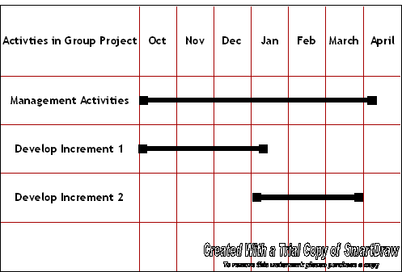

Chart 9.a: Tasks for Increment 1

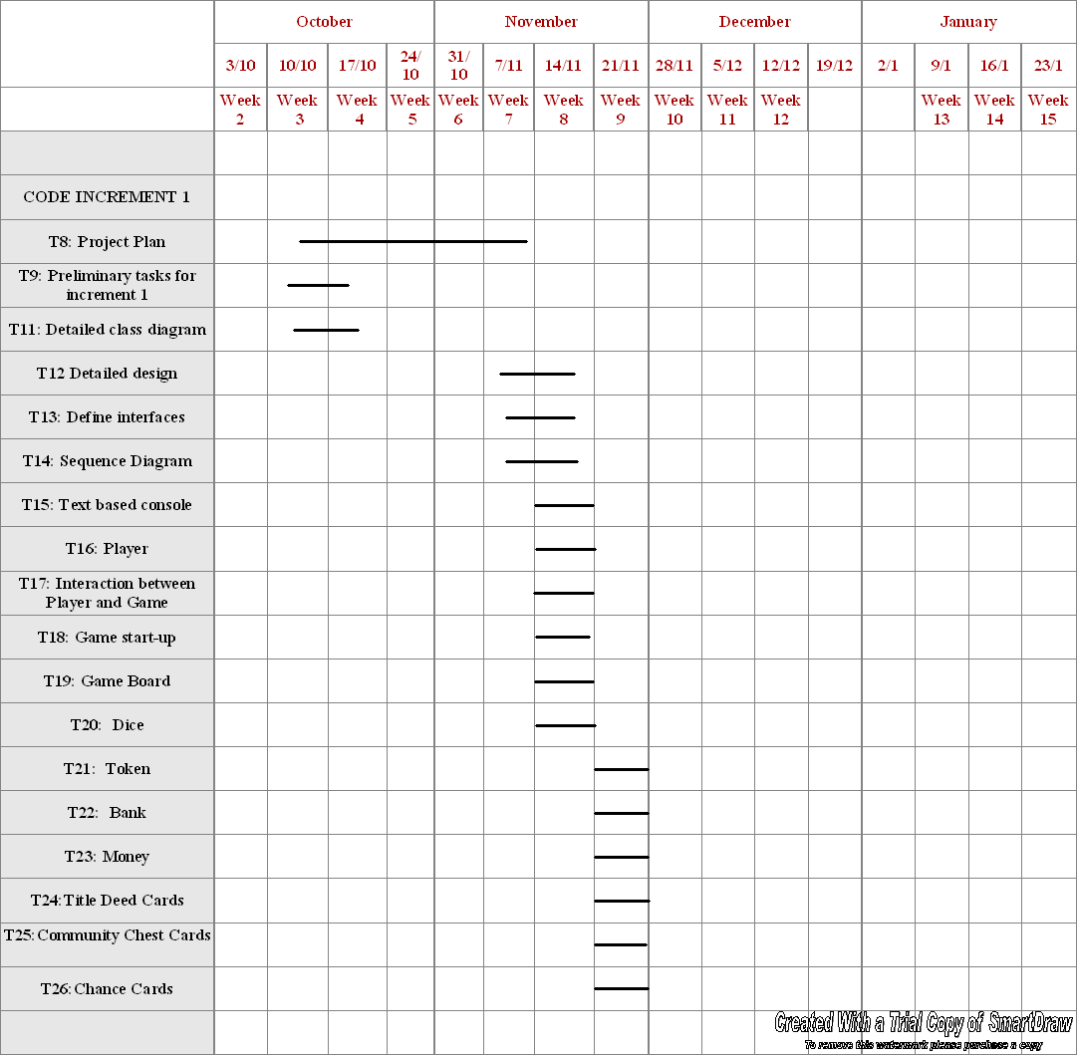

Chart 9.b: Tasks for Increment 1

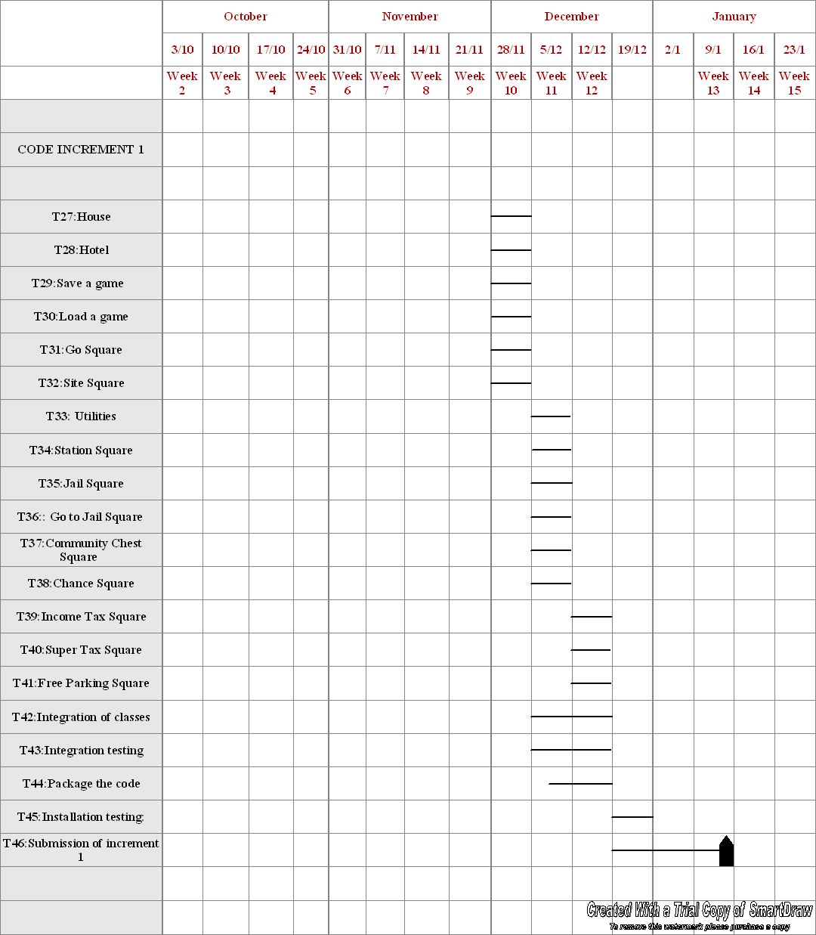

Chart 10: Tasks for Increment 2

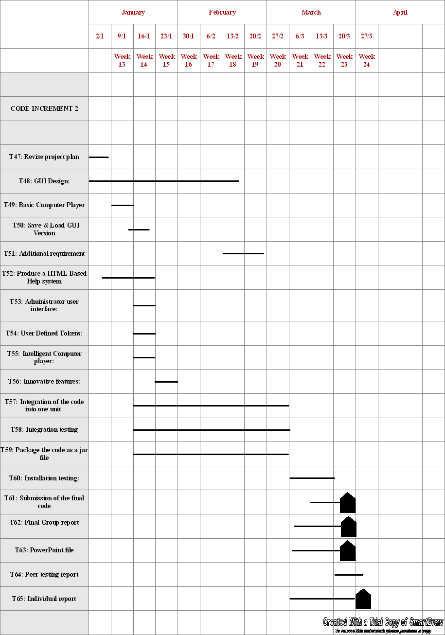

4.4 Individual work breakdown for increment 1

Table 11: Individual work breakdown for Increment 1

Task | Dependencies | Start | End | Total effort (days) | Individual effort allocation ( In Hours)
 |  |  |  |  | AB | CD | EF | GH | IJ | KL
T9 |  | 12/10/2005 | 19/10/2005 | 4 | 1 | 1 | 1 | 1 | 1 | 1
T10 |  | 13/10/2005 | 13/10/2005 | 1 |  |  |  |  | 1
T11 | T8 | 13/10/2005 | 19/10/2005 | 4 |  |  | 2 | 2
T12 | T8, T11 | 08/11/2005 | 16/11/2005 | 4 | 2 |  |  |  |  | 2
T13 | T8, T11, T12 | 08/11/2005 | 16/11/2005 | 2 |  | 2 |  |  | 2
T14 | T11-T13 | 08/11/2005 | 16/11/2005 | 2 | 1 | 2 | 1 | 1 | 2 | 1
T15 | T11, T12, T14 | 16/11/2005 | 18/11/2005 | 3 | 3 | 3
T16 | T11, T12, T14 | 16/11/2005 | 18/11/2005 | 3 |  |  | 3 | 3
T17 | T11, T12, T14 | 16/11/2005 | 18/11/2005 | 3 |  |  |  |  | 3 | 3
T18 | T11, T12, T14 | 19/11/2005 | 21/11/2005 | 3 |  |  |  |  | 3 | 3
T19 | T11, T12, T14 | 19/11/2005 | 21/11/2005 | 3 |  |  | 3 | 3
T20 | T11, T12, T14 | 19/11/2005 | 21/11/2005 | 3 | 3 | 3
T21 | T11, T12, T14 | 22/11/2005 | 24/11/2005 | 3 |  |  | 3 | 3
T22 | T11, T12, T14 | 22/11/2005 | 24/11/2005 | 3 | 3 | 3
T23 | T11, T12, T14 | 22/11/2005 | 24/11/2005 | 3 |  |  |  |  | 3 | 3
T24 | T11, T12, T14 | 25/11/2005 | 27/11/2005 | 3 | 3 | 3
T25 | T11, T12, T14 | 25/11/2005 | 27/11/2005 | 3 |  |  | 3 | 3
T26 | T11, T12, T14 | 25/11/2005 | 27/11/2005 | 3 |  |  |  |  | 3 | 3
T27 | T11, T12, T14 | 28/11/2005 | 30/11/2005 | 3 |  |  | 3 | 3
T28 | T11, T12, T14 | 28/11/2005 | 30/11/2005 | 3 | 3 | 3
T29 | T11, T12, T14 | 28/11/2005 | 30/11/2005 | 3 |  |  |  |  | 3 | 3
T30 | T11, T12, T14 | 01/12/2005 | 03/12/2005 | 3 | 3 | 3
T31 | T11, T12, T14 | 01/12/2005 | 03/12/2005 | 3 |  |  |  |  | 3 | 3
T32 | T11, T12, T14 | 01/12/2005 | 03/12/2005 | 3 |  |  | 3 | 3
Task | Dependencies | Start | End | Effort | AB | CD | EF | GH | IJ | KL
T33 | T11, T12, T14 | 04/12/2005 | 06/12/2005 | 3 |  |  | 3 | 3
T34 | T11, T12, T14 | 04/12/2005 | 06/12/2005 | 3 |  |  |  |  | 3 | 3
T35 | T11, T12, T14 | 04/12/2005 | 06/12/2005 | 3 | 3 | 3
T36 | T11, T12, T14 | 07/12/2005 | 09/12/2005 | 3 | 3 | 3
T37 | T11, T12, T14 | 07/12/2005 | 09/12/2005 | 3 |  |  | 3 | 3
T38 | T11, T12, T14 | 07/12/2005 | 09/12/2005 | 3 |  |  |  |  | 3 | 3
T39 | T11, T12, T14 | 10/12/2005 | 12/12/2005 | 3 |  |  |  |  | 3 | 3
T40 | T11, T12, T14 | 10/12/2005 | 12/12/2005 | 3 |  |  | 3 | 3
T41 | T11, T12, T14 | 10/12/2005 | 12/12/2005 | 3 | 3 | 3
T42 | T11, T15-T40 | 05/12/2005 | 15/12/2005 | 4
T43 | T15-T40, T42 | 06/12/2005 | 17/12/2005 | 5 |  |  | 3 | 3
T44 | T42 | 10/12/2005 | 17/12/2005 | 3 |  |  | 2 |  | 2
T45 | T43, T44 | 18/12/2005 | 22/12/2005 | 5 |  | 3 |  |  |  | 3
T46 | T10-T45 | 22/12/2005 | 10/01/2006 | 5 | 2 | 1 | 1 | 1 | 1 | 1
 |  |  | TOTAL |  | 33 | 36 | 37 | 35 | 36 | 35

Table 12: Staff allocation for increment 1

 | 10 Oct | 17 Oct | 24 Oct | 31 Oct | 07 Nov | 14 Nov | 21 Nov | 28 Nov | 05 Dec | 12 Dec | 19 Dec | 26 Dec | 02 Jan | 09 Jan
AB |  | T8
 | T9 |  |  |  | T12 |  | T22 | T28 | T35 | T41 | T46
 |  |  |  |  | T14 | T15 | T24 | T30 | T36
 |  |  |  |  |  | T20
CD |  | T8
 | T9 |  |  |  | T13 | T15 | T22 | T28 | T35 | T41 | T45
 |  |  |  |  | T14 | T20 | T24 | T30 | T36 |  | T46
EF |  | T8
 | T9 |  |  |  | T14 | T16 | T21 | T27 | T33 | T40
 | T11 |  |  |  |  | T19 | T25 | T32 | T37
 |  |  |  |  |  |  |  |  | T43
 |  |  |  |  |  |  |  |  |  | T44 | T46
GH |  | T8
 | T9 |  |  |  | T14 | T16 | T21 | T27 | T33 | T40
 | T11 |  |  |  |  | T19 | T25 | T32 | T37
 |  |  |  |  |  |  |  |  | T43
 |  |  |  |  |  |  |  |  |  |  | T46
IJ |  | T8
 | T9 |  |  |  | T14 | T17 | T23 | T29 | T34 | T39
 | T10 |  |  |  |  | T18 | T26 | T31 | T38 | T44
 | T13 |  |  |  |  |  |  |  |  |  | T46
KL |  | T8
 | T9 |  |  |  | T14 | T17 | T23 | T29 | T34 | T39
 |  |  |  |  |  | T18 | T26 | T31 | T38 |  | T46

5. Configuration Management
Roger Pressman, in his book, Software Engineering: A Practitioner’s Approach, says that Software Configuration Management (SCM) is a “set of activities designed to control change by identifying the work products that are likely to change, establishing relationships among them, defining mechanisms for managing different versions of these work products, controlling the changes imposed, and auditing and reporting on the changes made.” In other words, SCM is a methodology to control and manage a software development project.
5.1 Document Identification: In this group project the following documents are the ones that we are working with:
- All types of code files
- Drivers for tests
- Analysis and design documents
- User and developer manuals.
5.2 Baselines: The baselines for the group project are defined to be:
- Baseline A: The API of the program is completely defined; the bodies of the methods are empty.
- Baseline B: The program meets the requirement for increment 1; a text based version of the game has been implemented and tested.
- Baseline C: Basic GUI is implemented and has been integrated with the code for the text based version.
- Baseline D: The test phase of the basic GUI has been completed.
- Baseline E: Additional features have been implemented and tested.

- 5.3: Software
- Software to achieve configuration Management: The Configuration Manager will be required to familiarize himself with Star Team which is a plug-in for the Eclipse IDE. The reason for this is the capabilities of Star Team. Star Team provides the benefits of integrated version control, requirements, and change management; task and process management; and knowledge sharing. The integration between these capabilities improves performance and communication between the team.

6. References
[1] Fenton NE, “Software Engineering Group Project 2005-06: Problem Definition”, Queen Mary University, Sept 2005
[2] DCS235: Software Engineering Group Project 2005-06 : Guidelines, Schedule and Assessment”, Version 0.2,6 Oct 2005
[3] Course web site:
https://www.dcs.qmul.ac.uk/intranet/courses/ug/coursenotes/DCS235/
http://www.dcs.qmul.ac.uk/~norman/SE-pages
[4] Fenton NE, “Improving Your Technical Writing”, Queen Mary University, Oct 2004.
[5] Beck, Kent., Extreme programming explained : embrace change
Publisher: Addison-Wesley, 2000.
[6] The Monopoly game website:
http://www.hasbro.com/monopoly/
[7] Borland website for Star Team:
http://bdn.borland.com/article/0,1410,32991,00.html#collaborating
[8] Information on Configuration Management
http://en.wikipedia.org/wiki/Software_Configuration_Management
[9] Larman, Craig. Applying UML and patterns: an introduction to object-oriented analysis and design, Publisher: Prentice Hall PTR, 1998.

O'Connell, Fergus. How to run successful projects Publisher: Prentice-Hall, Pub date: 1994.
http://www.hasbro.com/common/instruct/MonopolyDeluxeEdition.PDF
http://en.wikipedia.org/wiki/Software_Configuration_Management
http://bdn.borland.com/article/0,1410,32991,00.html#collaborating

